IOT BASED SMART WASTE SEGREGATION SYSTEM FOR SUSTAINABLE DEVELOPMENT

**Abstract-** Urban India Generates tonnes of wastes annualy .Our country faces major challenges associated with waste management. It is noteworthy that waste management becomes challenging when segregation of the garbage is not performed and recyclables, organic waste and toxic wastes are all dumped together. Increasing putting additional pressure on landfill sites located in urban areas. sustainable waste management practices have became challenging due to our consumption and changing socioeconomic conditions. Waste management is the multidimensional problem that requires technology, economics, and socio cultural and political activities logo to hands in hand. This article focus on implementing and developing to update on advanced waste management technology using IOT. This system segregates the waste in to bio degradable, non- bio degradable wastes.to timely dispose the waste by level indication using Sensors .if it is bio-degradable waste it makes into compost a good fertilizing agent for farming land. The system design combines existing IOT infrastructure by segregating the waste in categories and reduce the wastage of human power and reduce pollution.

**Keywords -** Sustainable wastes ,Internet of Things, Sensors, wastes and machine learning model and Raspberry pi

**Introduction -** The abundant increase in the population led to improper disposal of wastes. managing the garbage requires more time and the lots of man power .in this era the waste disposal becoming the huge cause.The most common method of waste disposal is unplanned and it dumped in the land fill causes ill effects and the quality of water index is very much affected and burning fuels reduce the air quality index and causes the environmental degradation.Thus this article segregates the wastes in mainly three classes namely Biodegradable, non- bio degradable and bio medical wastes.

The merit of doing in this type of segregation there is no  need to rag pickers to segregate these wastes and the human potential is reduced .The proposed system is Mainly focusing on identification and Segregation of wastes. The separation by using Machine learning models .this type of systems are capaple of indicating the level of Wastes filling in the trash can and also avoid Health hazards.

**Existing System -** Waste management system are The recent survey urban india produces about 42.0 million tons of municipal wastes annualy.1.15 lakh metric tons per day .the Existing system has no proper planning regarding the collection of garbage which makes urban and rural into unhygienic.by using truck to collect the bulk wastes

.the labours who are cleaning the dustbins are not taking any responsibility which makes the  worse at urgent cases .proper monitering and disposal of wastes is obligatory to run the city clean and green .the conservative and and manual garbage monitering collection system now available .the labour can’t always monitor the elevation and scent of around the dustbin mannualy around all places of city .

No internet technology oriented system which is more effective. n the previous waste management systems, there was a lack of effective segregation and treatment methods for different types of

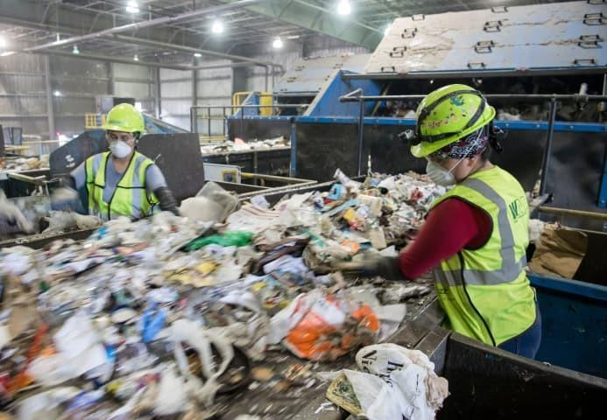

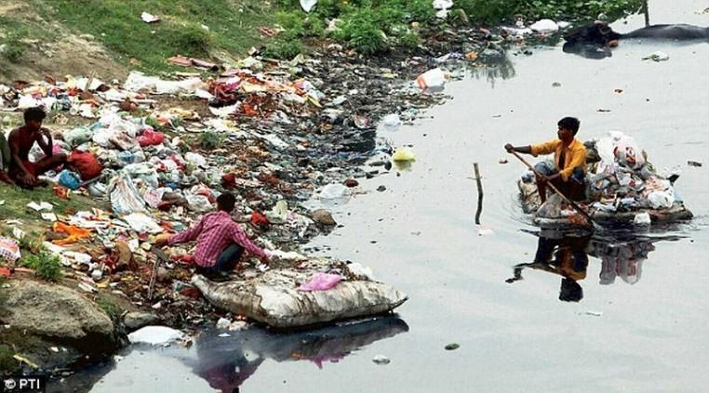

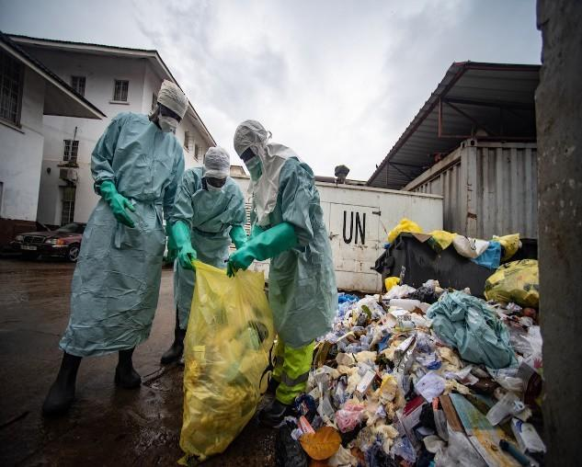

**Methodology** - Machine learning algorithm Microsoft lobe is used to train , Our model.for the purpose of Training we use a set a dataset Consist of 3 category images Such as bio degradegradable ,Non biodegradable and medical Wastes .

**Mechanical Setup -** To move the waste from One end another ,here we use the Convert Belt System.

For sorting of waste we use a Rotatable hand with  the Help of DC motor.

**Advantages -** It avoids direct human intervention with wastes there by there by protecting the from various hazardous and health issues.it reduces the time and man power for segregation of wastes by manual method and accuracy of segregation is increased .based on IOT technology smart Waste management vaims to optimize resource allocations ,reduce running cost and increase sustainability of waste services.

**Result Analysis -** Waste management is intended to reduce adverse effect of waste of human health,hazards,planetary resource and aesthetics.its main goals is to reduce environmental pollution

In future advancements are after Segregation we can recycle and make fertilizers and from non-bio degradable waste we can reuse and make new usable materials .from medical wastes to dispose them safetly by using UVrays.

**Future Scope**

Raspberry pi = orange omega 2+ Rubber or heavy materials

Used in conveyer in future used as PVC

**Conclusion**

The proposed this solution only because instead of using of using workers \humans to separates the wastes. which causes health and environmental hazards.we thought of using the technology to classify the wastes, garbages into different segments and making manure and compost to maintain the better health and clean and hygenic society

It is our responsibility to create “clean and greensociety”.